Visit MyAllen homepage my.allenuniversity.edu/ICS/ and click Login in the top right corner.
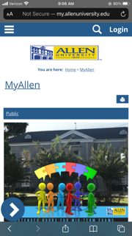
Enter username (jdoe12) and temporary password (Allen@2020).
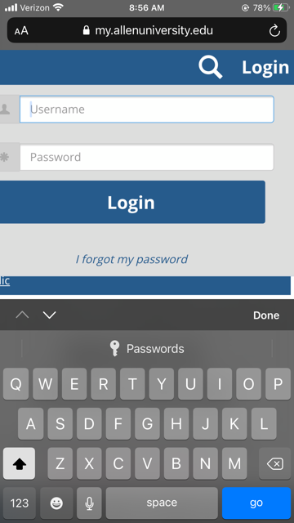
Click the arrow at the bottom left corner and select Password Management.
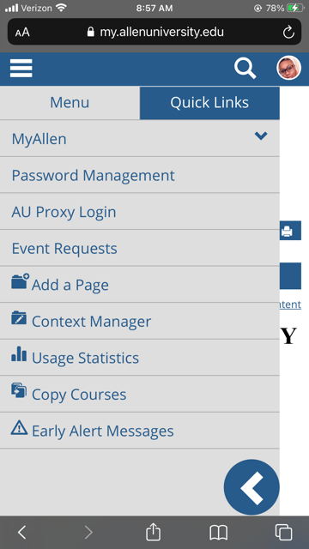
Enter temporary password in the Old Password box and create a new password. Your new password cannot be similar to any part of your name or username. It must be at least eight characters long, contain at least one uppercase letter, one lowercase letter, and one number. Lastly, it must contain one special character (ex.! @, #, $, %,&,*).
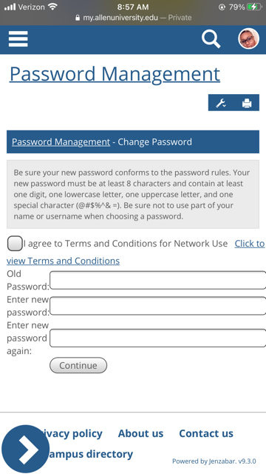
Agee to Terms and Conditions for Network Use and your password will update successfully.

